|  |
| --- |
| **This assignment should take an average student who is up-to-date with tutorial work approximately 25 hours**  **Deadline: your work must be submitted before the last week of this semester.** |

|  |
| --- |
| **Plagiarism is presenting somebody else’s work as your own. It includes copying information directly from the Web or books without referencing the material; submitting joint assignment as an individual effort; copying another student’s assignment; stealing or buying assignment from someone else and submitting it as your own work.  Suspected plagiarism will be investigated and if found to have occurred will be dealt with according to the procedures set down by the University.   All material copied or amended from any source (e.g. internet, books) must be referenced correctly according to the reference style you are using.** |

**1>Detailed Specification**

This is an individual assignment.

You are asked to provide a web application for Student Grade Management System at FPT University (I know, FPT already got one, but let assume we are reconstructing it).

You can use existing sources to develop your design including: fap.fpt.edu.vn, flm.fpt.edu.vn, ...

* All semesters, your instructors will be required to grade student exams. These assessments are identified in the respective subject’s syllabus. Figure 1 illustrates the assessments declared for PRJ301.

Figure 1: Assessment of PRJ301.

* Instructors will enter grades for the classes they were previously assigned through a screen similar to *Figure 2*.

Figure 2: Grading screen of the instructor for the assigned course.

* The student can track his/her academic transcript.

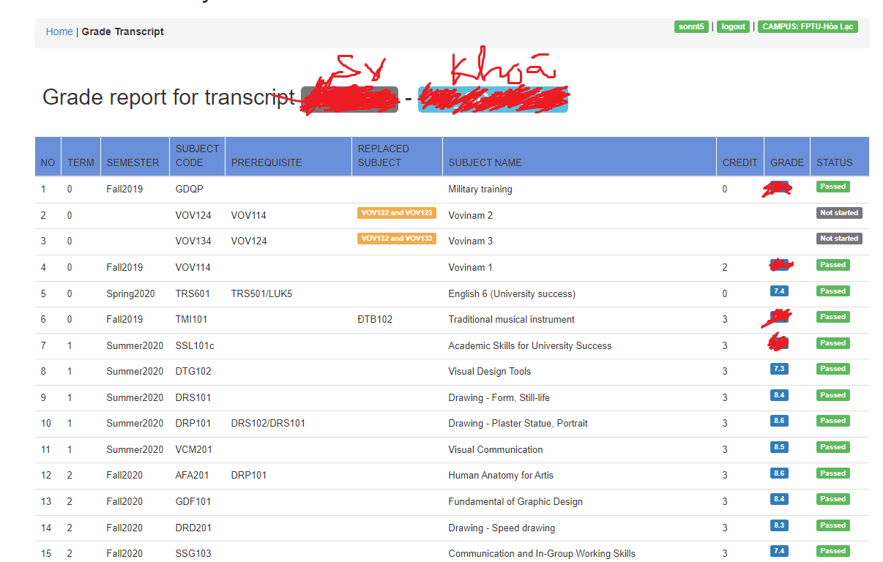

* Other roles in the system may also have corresponding statistical reports for example:

Instructors: can track the pass/fail rate in the class they teach.

Training: can monitor the pass/fail rate of each subject for each semester. This is important because it changes their original plan to open classes.

Testing: can monitor the abnormal score rate of specific subjects.

A complete system has many functions. You can't complete it all with limited resources. Please select the main functions to perform for this subject (hint: the screens listed above should be considered)